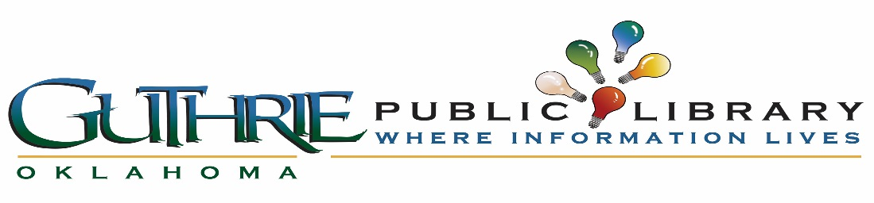
_____________________________________________________________________________________________
Guthrie Public Library Board Agenda
Library Conference Room
201 N Division, Guthrie, OK 73044
July 20, 2017 – 5:00 pm to 5:30 pm – Thank you to previous board members
July 20, 2017 @5:30 pm – Board Meeting
_____________________________________________________________________________________________

I. Thank you to previous board members
II. Call to order
III. Roll call and establish quorum
IV. Approve Minutes
V. Citizens to be Heard

Old Business

VI. ILL Policy
VII. Public Relations Committee
VII. Budget Committee

New Business

X. President
XI. Secretary
XII. Logo
XIII. Earthquake Policy – as of May 1, 2017
XIV. Inclement Weather Policy – as of May 1, 2017
XV. Building Committee
XVI. Reciprocal Card with Langston and Guthrie Public Library
XVII. Working Board (what does that look like?) (monthly hours?)
XVIII. Literacy Board
XIX. Library Budget
XX. Library as a County Library
XXI. Grants/(State Aide/USDA/OneGas)
XXII. Next Meeting
XXIII. Meeting Adjourned

_______________________________________________________________________________________________________________ Agenda posted on the bulletin board in the lobby of City Hall by 5:00 pm on Monday, July 17, 2017. The City of Guthrie encourages participation from all its citizens. If participation of any public meeting is not possible due to a disability, notification to the City Clerk at least 48 hours prior to the scheduled meeting is encouraged to make necessary accommodations. The City of Guthrie may waive the 48 hours rule if signing is not the necessary accommodation.
__________________________________________________________________________________________________________________________________________________________________________________

