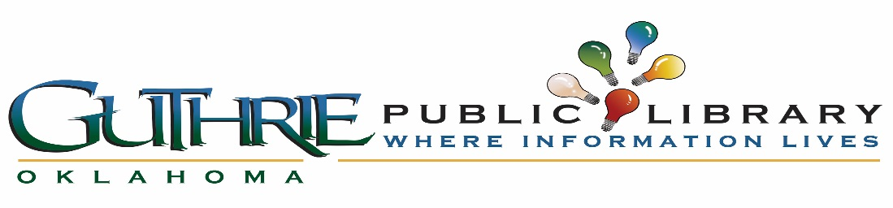
_____________________________________________________________________________________________
Guthrie Public Library Board Meeting Minutes
Library Conference Room
201 N Division, Guthrie, OK 73044
January 18, 2018 @5:30 pm
____________________________________________________________________________________________
I. Call to order: Called to order at 5:37 p.m.
II. Roll call and establish quorum: People in attendance were Candy Ford, Suzette Chang, Gary Dickerson, Nikki Kesler, and Angie Simonton
III. Approve Minutes: Candy Ford motioned and Angie Simonton seconded and was passed unanimously.
IV. Citizens to be heard: None on this date.

Old Business

V. Literacy Board-Literacy Coordinator Melanie Jenkinson was not able to attend the meeting, but she sent the following information that Ms. Chang presented for her.
Instead of purchasing or identifying programs to purchase, Ms. Jenkinson will first recruit students and tailor their needs into an individual program. One of the places for recruitment will be through local Guthrie churches. The motion was made by Ms. Simonton to table this discussion until Ms. Jenkinson is present. The motion was seconded by Mr. Dickerson. All were in favor.
VI. Two year plan (?): Ms. Chang presented a rough draft of the Strategic Plan. In it was a combination of policy, values of the City of Guthrie, objectives, etc. On page 6 there is space to place a timeline. Ms. Chang would like for members to contribute their ideas and work on this together so that the burden of the timeline does not fall on just one person.
VII. Marketing Committee: The committee met and came up with some great ideas to help with marketing. Ms. Kesler would like to volunteer to deliver calendars of upcoming events to local businesses and churches. Ms. Chang would like for us to tackle some of the committee’s suggestions in phases. See page 5 in the Strategic Plan for phases.
#1, 3, 6, 7 wait
#2, 4, 5, 12, 13, 16, 17 In progress
#8, 9, 18 Will be considered phase 1 and Ms. Kesler will begin implementation
#10, 11, 14 15 will be phase 2 (on hold for right now)
VIII. Reciprocal card with Metropolitan Library System (?): This is on hold indefinitely.
IX. 89er Day Celebration: Ms. Kesler wants to volunteer to help with the float along with other volunteers and library staff. It was discussed that this would be a great way to show off our new logo.
IX. Next Meeting: April, 19, 2018 at 5:30 p.m.
X. Meeting adjourned: 6:06 p.m.
Minutes faithfully submitted by Angie Simonton, Secretary

